|  |  |  |  |  |  |
| --- | --- | --- | --- | --- | --- |
| **获奖名单** | | | | | |
| **奖项** | **指导老师** | **团队成员** | | | |
| 一等奖 | 吴婷 | 组长 | 杨潇宇 | 210053 | 建筑学院 |
| **成**员 | 余青钱 | 210046 | 建筑学院 |
| 丁佳艺 | 210047 | 建筑学院 |
| 黄诗佳 | 210049 | 建筑学院 |
| 覃思远 | 210056 | 建筑学院 |
| 彭雅欣 | 210057 | 建筑学院 |
| 袁源 | 210067 | 建筑学院 |
| 一等奖 | 张豫 | 组长 | 刘瑞之 | 215190 | 网络空间安全学院 |
| 组员 | 蔡月啸 | 215202 | 网络空间安全学院 |
| 张铨炜 | 215201 | 网络空间安全学院 |
| 曹越 | 215177 | 网络空间安全学院 |
| 董浩 | 215180 | 网络空间安全学院 |
| 陈浩杰 | 215183 | 网络空间安全学院 |
| 一等奖 | 李黎 | 组长 | 陈轶男 | 210083 | 建筑学院 |
| 成员 | 何宇皓 | 210084 | 建筑学院 |
| 姚秀凝 | 210092 | 建筑学院 |
| 邹雅眉 | 210109 | 建筑学院 |
| 邱子倍 | 210113 | 建筑学院 |
| 麦洁鸣 | 210116 | 建筑学院 |
| 二等奖 | 刘彬 | 组长 | 关曙雷 | 214395 | 人文学院 |
| 成员 | 张岭南 | 214387 | 人文学院 |
| 管雨欣 | 214391 | 人文学院 |
| 李佳营 | 214388 | 人文学院 |
| 赵雯钰 | 214390 | 人文学院 |
| 张安然 | 214394 | 人文学院 |
| 张家琪 | 214397 | 人文学院 |
| 王可妮 | 214413 | 人文学院 |
| 二等奖 | 蔡旭东 | 组长 | 胡语涵 | 211964 | 自动化学院 |
| 成员 | 李萱露 | 211923 | 自动化学院 |
| 方娱 | 211942 | 自动化学院 |
| 陈鑫 | 211950 | 自动化学院 |
| 张文康 | 211962 | 自动化学院 |
| 韩江云 | 211966 | 自动化学院 |
| 二等奖 | 蒯劲超 | 组长 | 张笑颜 | 211658 | 电子学院 |
| 成员 | 杨凯悦 | 211657 | 电子学院 |
| 王欣茹 | 211671 | 电子学院 |
| 刘玉洁 | 211654 | 电子学院 |
| 程星全 | 211685 | 电子学院 |
| 宋仟仟 | 211655 | 电子学院 |
| 李可 | 211690 | 电子学院 |
| 二等奖 | 蒋欣欣 | 组长 | 宋丹玉 | 210032 | 建筑学院 |
| 成员 | 崔金小雨 | 210034 | 建筑学院 |
| 杨淼 | 210030 | 建筑学院 |
| 秦晓彤 | 210031 | 建筑学院 |
| 庄惟中 | 216235 | 建筑学院 |
| 范立文 | 210029 | 建筑学院 |

（注：三等奖名单另行通知。）

The 10th SEU Postgraduate Simulated International Conference Contest Successfully Held

The 10th SEU Postgraduate Simulated International Conference Contest was successfully held in the Lecture Hall of the School of Foreign Languages (SFL) on the afternoon of May 18, 2022. After two-round matches, 7 teams entered the final, who presented the audience their own researches and organized 7 mini international academic conferences, an academic feast of multiple disciplines in English.

Each conference was composed of sessions of opening speech, introduction of keynote speakers, keynote speech, Q&A, and closing speech. The group members acted as the host, the conference chair, the keynote introducer, keynote speakers, etc., for the corresponding sessions.

The research topics of each team were cutting-edge. With unique and sharp insight, precise and fluent English language, confident manner, and amiable interaction, the contestants fully demonstrated the talented competence required of a “Double First-class” university. Finally, three teams from School of Architecture and School of Cyberspace Security won the first prize, and the remaining four finalists won the second prize.

To cultivate students of international vision and further improve the academic English communication ability of postgraduates, the teaching team of Academic English Course of the Department of English Teaching for Graduate Students, SFL, has provided many practical opportunities for the master and doctoral students in SEU. As one of the teaching achievements, the Postgraduate Simulated International Conference Contest has been successfully held for ten consecutive years so far. The event was designed to encourage graduate students to practice, communicate and innovate, to lay a solid foundation for international exchanges, and to fully prepare students for telling China stories to the rest of the world on the international academic stage. What’s more, this event helps to achieve the curriculum objectives, serves as one of the education strategies of SEU internationalization, and comprehensively promotes the quality and efficiency of talent training in the new era.

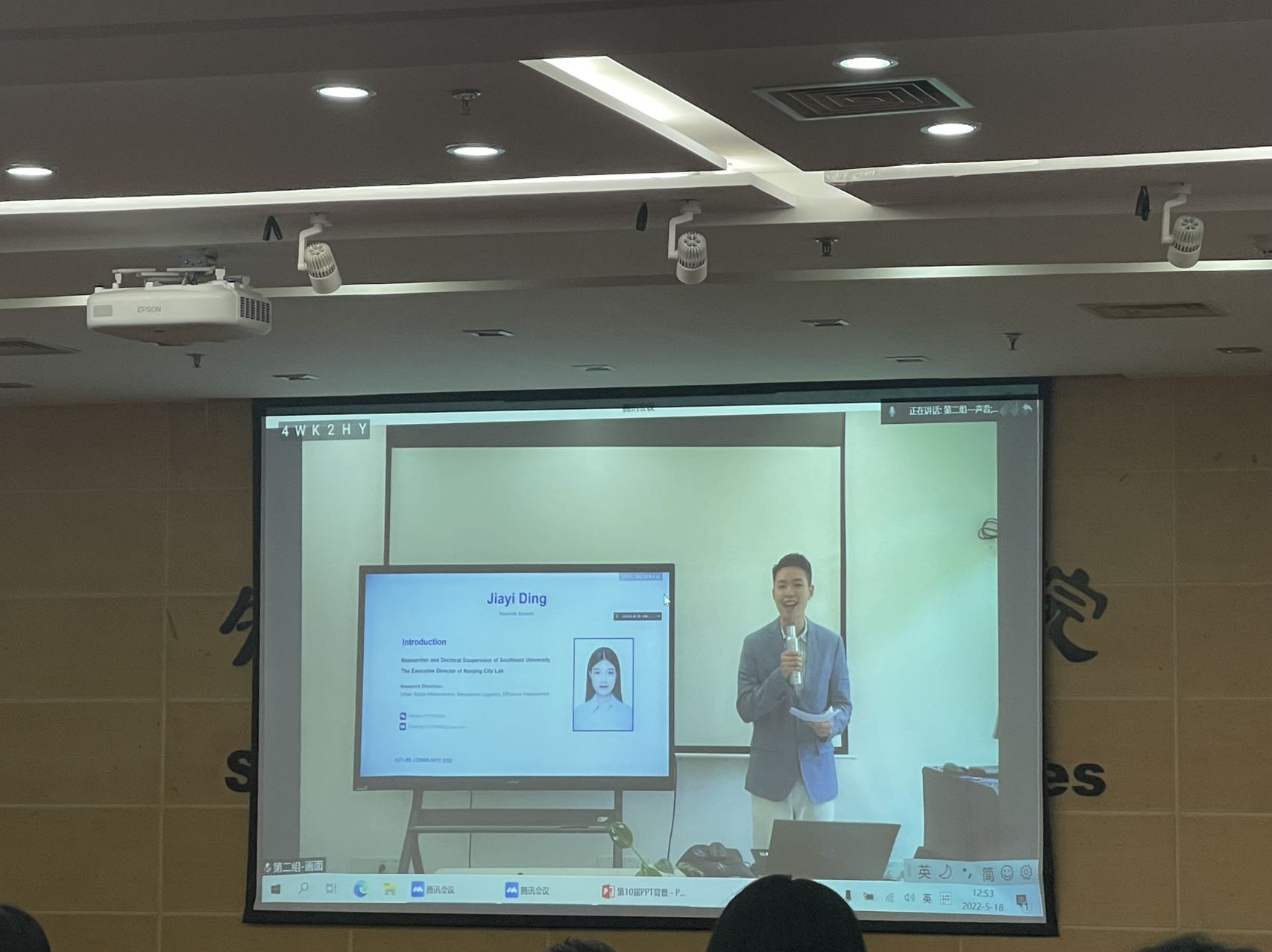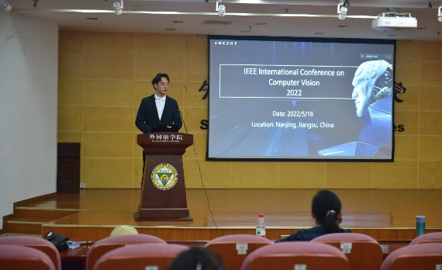

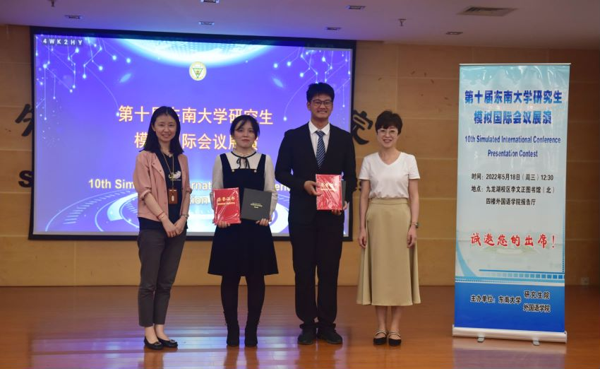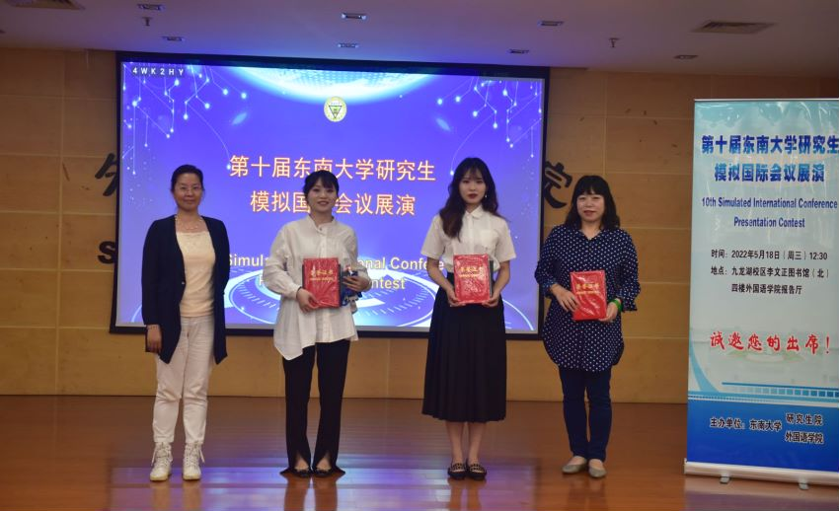

Reported by Wang Min, Li Li

Translated by Fan Rong, Li Li, Ling Jianhui

Photographed by Shi Chen, Jin Jing